**Data Migrator 1.0.1**

**Product Details**

Product Name: Climate Data Migrator  
Product Version : 1.0.1.*

Changes From Version 1.0.0.*: Bug fixed for SOIL_TEMP and SOIL_MOISTURE for site scan.

Note: This product requires R 3.1.1. Please install R 3.1.1 on the directory: “C:\Program Files\R” before using this product

Installation Instructions:

1. Click on setup.exe. Then setup dialog box appears as below:

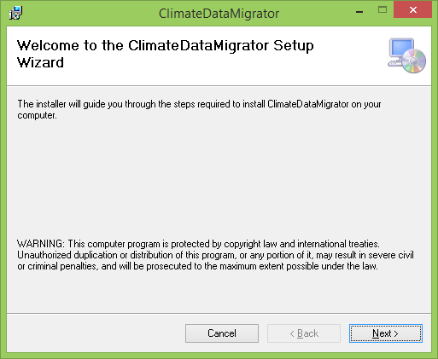

1. Click next. Default installation is “C:\Program Files (x86)\Jornada\ClimateDataMigrator\” change if necessary. Select the users of PC who will see the product. Default is only me. And then click next as below:

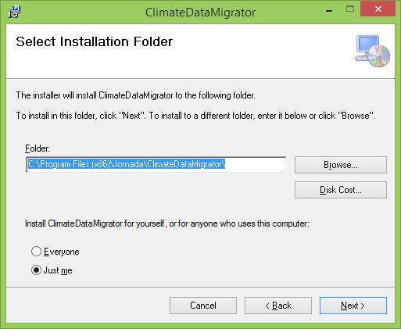

1. Click Next.

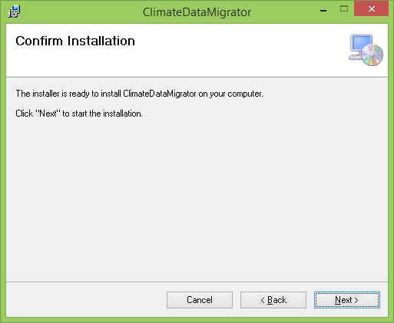

1. Click Next and Installation Complete dialog appears. Then click close

